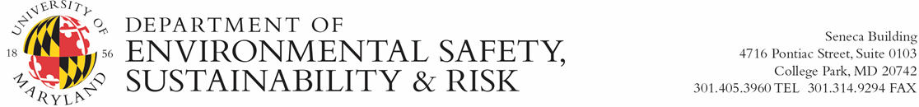

Needs Assessment for Research Safety, OSH, and Environmental Reviews
Provide project information and check any boxes that apply to submitted project. Submit to firemarshalreview@umd.edu.
Project Number: Click or tap here to enter text. Project Manager:Click or tap here to enter text.

Project Name (if applicable): Click or tap here to enter text. Submission Date: Click or tap here to enter text.
☐ None of the following project elements apply to this project

Research Safety (check all that apply)
☐ Construction of new laboratory space
☐ Demolition and/or renovation of existing laboratory space
☐ Installation and/or replacement of chemical fume hood and/or biosafety cabinets
☐ Installation of snorkels or other local exhaust systems
☐ Renovation and/or construction of HVAC systems that serve laboratory spaces
☐ Replacement or installation of emergency eyewashes and/or showers
☐ Installation of an autoclave
☐ Installation of an environmental chamber
☐ Installation and/or removal of electromagnetic, laser (curtain), or radiation shielding
☐ Installation of an ionizing or non-ionizing radiation generating device (e.g., x-ray machine, accelerator, NMR, MRI)
☐ Installation of ceiling/wall mounted germicidal ultraviolet (GUVC) lights for air/room sterilization
☐ Construction, renovation, and/or demolition of animal rooms
☐ Consideration of enthalpy wheel installation where exhaust includes laboratories
☐ Construction requires radiography testing. [Advanced notification to RSO required: radiationsafety@umd.edu.]
☐ Space has planned use of cryogens (including recovery systems)
☐ Space has planned use of open beam Class 3b or 4 lasers
☐ Space has planned use of biological materials
☐ Space has planned use of radioactive materials

Occupational Safety and Health (OSH) (check all that apply)
☐ Construction or renovation of a machine shop or permanent welding area
☐ Installation of 3D printers, laser cutter/engravers, and/or soldering stations (lab and non-lab locations)
☐ Modification, installation, removal, or replacement of natural gas system
☐ Installation of a permanent confined space
☐ Installation of permanent cranes or hoists
☐ Installation of emergency eyewash or showers (non-laboratory locations)
☐ Installation of chemical storage facilities (non-laboratory locations)
☐ Installation of measures necessitating fall protection (e.g., scaffolding) or fall protection systems (e.g., attachment points)
☐ Installation of pressure vessels and/or boilers
☐ Construction or renovation expected to impact and/or encounter known or suspected hazardous and/or regulated materials
(e.g., asbestos, lead, mercury, silica from masonry, PCBs, refrigerants, etc.)

Environmental Affairs (check all that apply)
☐ Installation and/or replacement of fuel burning equipment including generators, turbines/micro turbines, furnaces, boilers, fire pumps, grills/charbroilers, or autoclaves
☐ Installation and/or replacement of fuel storage tanks
☐ Introduction of new discharges to stormwater system including condensate, cooling towers, floor drains, or sump pumps
☐ Installation of oil/water separators

