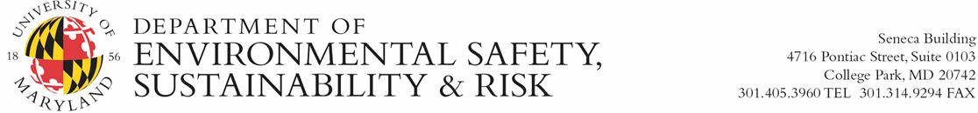

Research Specific Training for Field Work

☐ The principal investigator has reviewed the Field Hazard Assessment with the employee/student and provided a copy.
☐ The principal investigator has reviewed Emergency Response Plan with the employee/student and provided a copy.
☐ The principal investigator has reviewed the nature and scope of field work with the employee/student.
☐ Indicate recommended medical evaluations and/or immunizations:

☐ The employee/student has received instruction on specific procedures to be performed in the field.
☐ The employee/student has demonstrated competency.
☐ The principal investigator has reviewed and provided copies of all Standard Operating Procedures and applicable manuals to the employee/student.
☐ The principal investigator has identified that the following additional training is required:
☐ Standard First Aid/CPR
☐ Wilderness First Aid
☐ Bloodborne Pathogens
☐ Scientific Diving
☐ Respiratory Protection
☐ Animal User Training
☐ Other (Indicate)

☐ The principal investigator has provided the employee/student appropriate Personal Protective Equipment and instructed on appropriate use.
☐ Indicate required PPE:

☐ Covered decontamination, removal, and disposal procedures.
☐ The principal investigator has reviewed any restrictions regarding permitting and site access with the employee/student.
☐ The principal investigator has provided the employee/student with training on maintenance and care of mechanical equipment and other required gear.
☐ The principal investigator has reviewed the disposal plan for waste generated in the field with the employee/student.
☐ The principal investigator has provided instruction on use of emergency safety equipment and supplies.
☐ The principal investigator has reviewed incident reporting procedures with the employee/student.
☐ The principal investigator has defined circumstances when, and how, the itinerary can be changed due to safety concerns.

Employee/Student Signature __________________________________________________ Date__________

Principal Investigator Signature ________________________________________________ Date__________

